

STATE OF ISRAEL

MASHAV - Israel’s Agency for International

Development Cooperation

with

The A. Ofri International Training Center

invite professionals

to participate in the

International Course:

Israel's Agency for International

Development Cooperation Ministry of Foreign Affairs
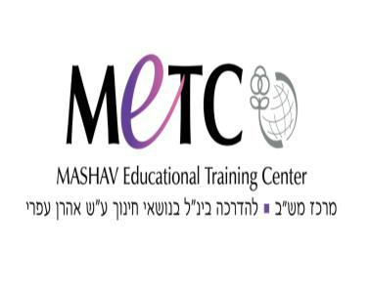

Education for Sustainable Development

14

14/5-9/6/2017
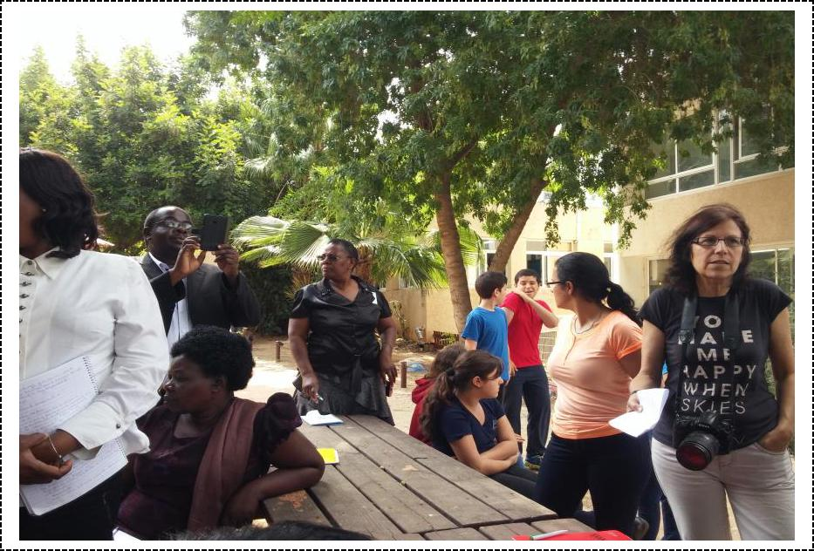

החולש םש

About the Course

Background

“Education Towards Sustainable Development (ESD) meets the needs of the present generation without compromising the ability of future generations to meet their own needs”

Brundtland Commission, United Nations, March 20, 1987

Education for Sustainable Development (ESD) aims to preserve environmental integrity, economic viability, and a just society for present and future generations. ESD addresses these objectives through the establishment of broad teaching and learning processes that emphasize an interdisciplinary and holistic approach, which promotes critical and creative thinking in education. ESD pursues this endeavor with the understanding that human behavior may be altered to limit harmful effects on the environment.

In May, 2015, UNESCO’s Conference on World Education, held in Incheon Korea declared new Education goals for the year 2030. "Our vision is to transform lives through education, recognizing the important role of education as a main drive of development," the declaration reads. "Building on the legacy of Jomtien and Dakar, this Incheon Declaration is a historic commitment by all of us to transform lives through a new vision for education, with bold and innovative actions, to reach our ambitious goal by 2030." This new vision is embodied by the UN’s global goals for 2030, the Sustainable Development Goals, emphasizing the vision that in order to achieve equality and fight world poverty, all countries must commit to sustainable development.

Education for sustainable development (ESD) is not a particular programme or project, but is rather an umbrella for many forms of education that already exist, and new ones that remain to be created. ESD promotes efforts to rethink educational programmes and systems (both methods and contents) that currently support unsustainable societies. All educational programmes need to be based on five fundamental pillars of learning: Learning to know: Learning to do, Learning to live together; Learning to be; Learning to transform oneself and society

The Program adheres to the understanding that the promotion and implementation of ESD should become an integral element in school curriculum, and that the path to establish institutions based on the tenets of ESD requires thorough, long-term development and support activities.

The Program will follow the main principle of ESD to “Think Global, Act Local.” This principle involves combining the needs and resources available in developing countries to charter the path for the future and support Sustainable Development. The program will follow this principle by first assisting community members implement projects that will produce tangible results despite the wider scope of the needs of their communities. By doing so, the program will improve economies, societies, and the environment at the local and global levels.

Implementation of Education towards Sustainable Development in Schools

In theory, educational systems have the responsibility of spearheading orientation towards sustainable development. But actual experience shows that one of the main problems in introducing new subjects is the difficulty of their acceptance by formal educational systems.

Every school has to be open to this subject and begin a process of learning and internalization. Core Values of Education towards Sustainable Development

Respect for the environment

Democracy

Lifetime learning

Equality

Progress towards peace

Aims

2

- Development of self-identity and values reflecting the worldview of the teacher as an educator for sustainability

- Imparting of knowledge and information on current environmental, social and economic issues and the relationship between them

- Development of creative and flexible methods of thinking that will enable the identification of environmental and social problems and their solutions

- Introducing, understanding and practicing of integrative approaches to educational planning, through the creation of curricula combinations around a common principle – sustainability and sustainable development

- Development of professional and pedagogical skills
- Development of entrepreneurship and good citizenship, social and environmental leadership

Those who complete the program will be able to:

- Initiate, develop and lead educational and/or community projects dealing with complex socio-environmental-social issues

- Analyze projects in a reflective way so as to assess them with appropriate methodologies

Main Subjects

Society and Environment in the Era of Globalization

The Ecological Net

The Socio-Environmental Crisis and its Impact on Ecology

Cultural Interactions in the Era of Globalization

From Environmental Sciences to “Sustainability”

Basic Ideas

Analysis of Historical Processes

Sustainable Thinking, What Is It?

Basics and Research Analysis

Identification and Solving Conflicts

Socio-Environmental Leadership and Entrepreneurship

Learning from Successes

Leading Change Processes

Mapping as a Condition for Change

Leadership Development

Development of Sustainable Socio-Educational Projects

World-Wide Thinking and Local Action

Methodology

3

The Ofri International Training Center has developed a unique, holistic approach that takes into consideration the emotional and creative aspects of the pedagogical process. Its working methods enable program participants to make practical use of theoretical knowledge.

  - Lectures and discussions led by experts

  - Workshops
  - Analysis of educational planning through written material and professional visits

  - Meetings with institutional administrators and acquaintance with projects at the national and regional levels

- Simulations, panel discussions, and group work
- Preparation of final projects by individuals or groups

- Study tours at schools, educational centers, universities, teacher training institutions and pedagogical resource centers

Application

Application Requirements

For this course we would like to accept: Directors of Departments in MOE’s and municipalities Principals, Head teachers, Supervisors, Curricula Developers, Teachers of teachers.

Application forms should be sent to the relevant Israeli Mission before 17.3.2017

Application forms

Application forms and other information may be obtained at the nearest Israeli mission or at MASHAV’s website: http://mashav.mfa.gov.il/MFA/mashav/Courses/Pages/default.aspx.

Completed application forms, including the medical form, should be sent to the relevant Israeli mission in the respective country.

General Information

Arrival and Departure
Arrival date: | 14.5.2017
Opening date: | 155.2017
Closing date: | 8.6.2017
Departure date: | 9.6.2017

Participants must arrive at the training center on the arrival date, and leave on the departure date. Early arrivals/late departures if required, must be arranged by the participants themselves, directly with the hotel/center, and must be paid for by the participant him/herself.

Location and Accommodation

MASHAV awards a limited number of scholarships. The scholarship covers the cost of the training program including lectures and field visits, full board accommodation in double rooms (two participants per room), health insurance (see below) and transfers to and from the airport. Airfares and daily allowance are not included in the scholarship.

Health Services

Medical insurance covers medical services and hospitalization in case of emergency. It does not cover the treatment of chronic or serious diseases, specific medications taken by the participant on a regular basis, dental

4

care and eyeglasses. Health authorities recommend that visitors to Israel make sure they have been inoculated against tetanus in the last ten years. Subject to the full binding policy conditions. Participants are responsible for all other expenses.

The course will be held at the A. Ofri International Training Center, situated in the Ramat Rachel Hotel on the outskirts of Jerusalem. Participants will be accommodated in double rooms (two participants per room).

About MASHAV

MASHAV – Israel’s Agency for International Development Cooperation is dedicated to providing developing countries with the best of Israel’s experience in development and planning. As a member of the family of nations, The State of Israel is committed to fulfilling its responsibility to contribute to the fight against poverty and to the global efforts to achieve sustainable development. MASHAV, representing Israel and its people, focuses its efforts on capacity building, sharing relevant expertise accumulated during Israel's own development experience to empower governments, communities and individuals to improve their own lives.

MASHAV’s approach is to ensure social, economic and environmental sustainable development, and is taking active part in the international community’s process of shaping the Post-2015 Agenda, to define the new set of the global Sustainable Development Goals (SDGs).

MASHAV’s activities focus primarily on areas in which Israel has a competitive advantage, including agriculture and rural development; water resources management; entrepreneurship and innovation; community development; medicine and public health, empowerment of women and education. Professional programs are based on a “train the trainers” approach to institutional and human capacity building, and are conducted both in Israel and abroad. Project development is supported by the seconding of short and long-term experts, as well as on-site interventions. Since its establishment, MASHAV has promoted the centrality of human resource enrichment and institutional capacity building in the development process – an approach which has attained global consensus.

About the A. Ofri International Training Center

5

The A. Ofri International Training Center was established in 1989 as a professional extension of MASHAV - Israel’s Agency for International Development Cooperation. The activities are targeted to meet the Millennium Development Goals (MDGs) set by the United Nations to be fulfilled by the year 2015.

The Center's vision is that education is the starting point for a person to build himself/herself a gate to new possibilities. Education is the key to a better future and shields against physical harm and confronts moral dilemmas. Education enables us to ask for proper healthcare when needed, and the way to stay healthy and adopt responsible behavior with our bodies. Education is sharing, learning and growing up together with others. Through education we can learn to take better care of our world, treat it respectfully and use wisely the resources it offers us.

Education concerns itself with learning at all levels, from elementary and secondary school through adult education, and provides knowledge and training for basic skills development, civic awareness, community education, education for special populations, treatment for youth

(Including those at risk), youth integration, youth leadership, education for health and the prevention of drugs abuse.

Since its inception, the A. Ofri Center has trained thousands of professionals from countries throughout the world. The Center cooperates with senior staff in the Israeli Ministry of Education, academic experts, governmental organizations and non-governmental organizations. In addition, it communicates and cooperates with key international organizations such as UNESCO, OECD, USAID, UNODC, OAS, IOM and the World Bank.

In adopting the UN’s Millennium Development Goals, the A. Ofri Center contributes to the sustainable development of human resources internationally, based on knowledge and experience accumulated in Israel.

6

